**San Jose State University**

**Department of Computer Engineering**

**CMPE 125 Spring 2017**

**Lab 6 Report**

**Sequential Building Blocks**

**Date ______4/8/17__________**

**Name ___Anahit Sarao_______ SID ___008435583___**

**Name ____Maxwell Cheshier______ SID __009193717___**

**Lab Record**

| **Tasks** | **Designed by (print name)** | **Verified by (print name)** | **\*Completion Status** |
| --- | --- | --- | --- |
| **1** | Maxwell | Ryan | A |
| **2** | Anahit | Ryan | A |

**\* Enter the following:**

**A – if the task was successfully completed**

**B – if the task was partially completed**

**X – if the task was failed or not performed**

**If you entered B or X, detailed description about the incompletion or failure must be given in the report.**

***Introduction***

This lab consisted of two major tasks: design a 32 by 32 register file, and design a 8 by 4 FIFO. Both design tasks required simulation verification and the FIFO also required hardware verification. The register requirements included having two read ports and two write ports. This caused a design constraint where the read addresses needed to be unique. A self testing testbench was used to perform verification. The FIFO, also known as first in first out, represents a modularized queue. This queue is able to read and write 4-bits of data while checking for flags such as full, empty, reset, enable, read, write at all times.

The parts listed below were fully completed in lab:

* Verification stimuli and design of Register File
* Verification stimuli and design of FIFO
* Hardware Verification of FIFO

***Design Methodology***

*Register:* The register was to designed to be 32 bits wide and 32 bits deep. It was designed with two write ports and two read ports. The register was synchronous as it relied on the use of a clock and it also utilized two write enable ports. Each port was tested for functionality to ensure that they worked as designed. Other ports used in the operation of the register were read address ports, read data ports, write address ports, and write data ports. Each port was required for proper writing and reading of the data input to the register. The register was then checked using a self checking test bench. The signal ports and naming conventions can be seen in the figure below.

| **Signal Name** | **Definition** |
| --- | --- |
| Rd1[31:0] | Read from data port 1 |
| Ra1 [4:0] | Read address for data port 1 |
| Rd2[31:0] | Read from data port 2 |
| Ra2[4:0] | Read address for read data port 2 |
| Rd3[31:0] | Read data port 3 |
| Ra3[31:0] | Read address for read data port 3 |
| Wd1[31:0] | Write data port1 |
| Wa1[4:0] | Write address for write data port 1 |
| We1 | Write enable for write data port 1 |
| Wd2[31:0] | Write address for write data port 2 |
| Wa2[4:0] | Write address for write data port 2 |
| We2 | Write enable for write data port 2 |
| clk | Synchronous clock |
| D_Out1[31:0] | Data output from port 1 |
| D_Out2[31:0] | Data output from port 2 |
| D_Out3[31:0] | Data output from port 3 |

Table 1: Register File Input and Output

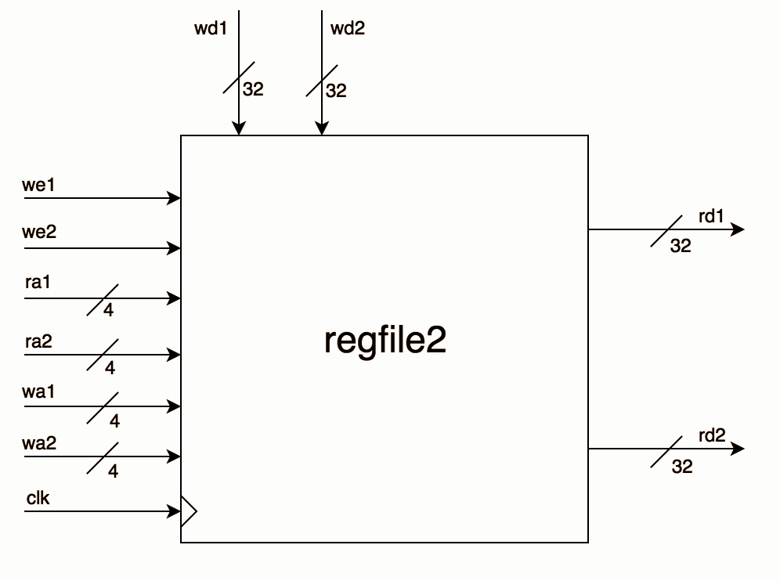

Figure 1: Register Block diagram with two input and two output ports

*FIFO:* The FIFO can be used as a queue to store eight values which are four bits long. The queue has a similar design to a functional D-register as it is synchronous and has a reset. However for a FIFO additions were made such as the enable, read, and write input signals. The design behind the enable can be compared to an on and off switch and the signal will enable or disable the FIFO. The read and write signal is triggered in relation to the input signal where 1 is write and 0 is read. Table 2 shows the input signals and which operations will be performed when the signals are sent in.

Table 2: FIFO Signals

| WNR | Enable | FIFO Operations |
| --- | --- | --- |
| x | 0 | 0 |
| 0 | 1 | Read |
| 1 | 1 | Write |

Figure 2: FIFO Block Diagram

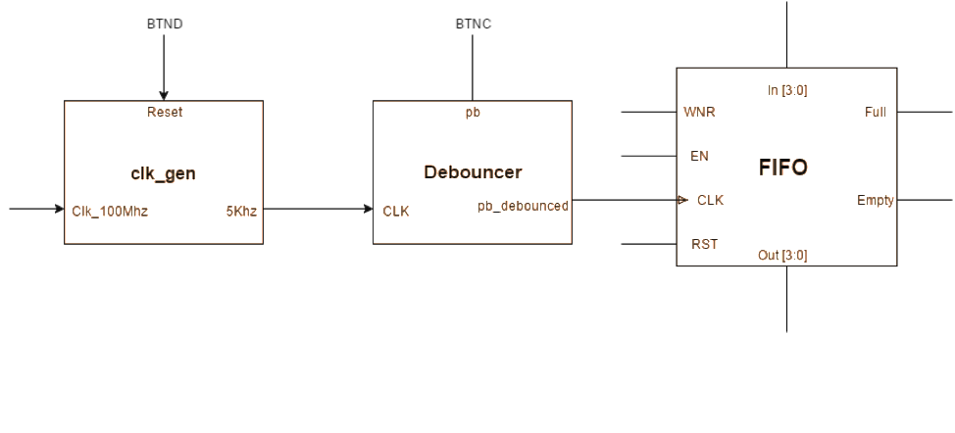

***Simulation Test Plan***

*Register:* A self checking test bench was implemented to verify the functionality of the register. There were 3 tests conducted to verify the functionality. The first test was a simple verification of the functionality of the write and read ports. Using a for loop, data was assigned to each port and then read from the write port. The next test verified the functionality of the write enable switches. The enable was turned off and values were given to the register. If the read ports received that data, then the module would fail the test. The last test was a test in which each write port was assigned the same address as the two read ports. Figure 3 shows the successful output of the register test.

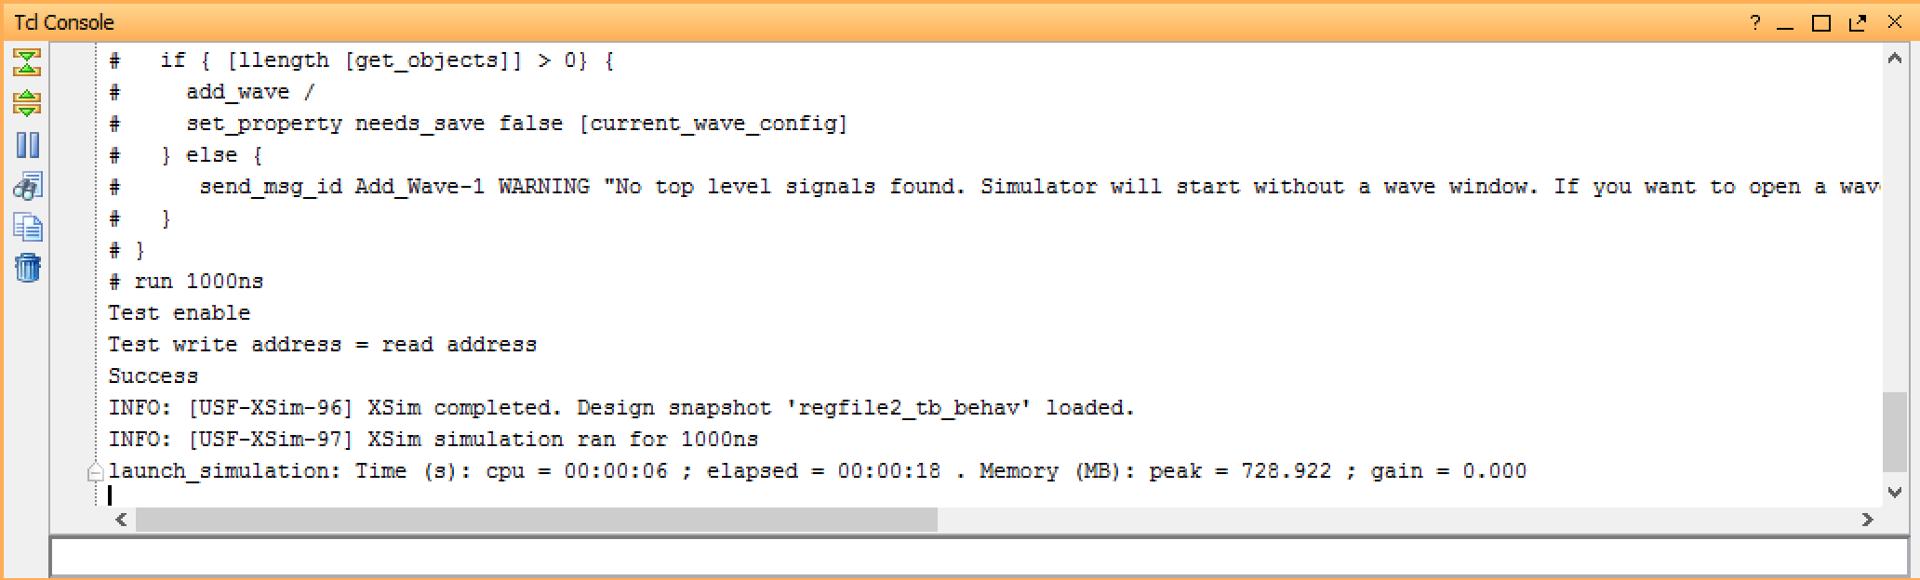

Figure 3: Simulation Output for Register

*FIFO:* A self testing testbench was used to verify the FIFO through waveforms. The test bench is designed to take in a four bit input, enable, wr, clk, and rst signals. Two tasks are created to be able to toggle the clock and reset the testbench. A loop is created to loop for an iteration of ten during the iterations the FIFO filled with values, and values are read. After the loop the FIFO is checked for certain flags such as empty, full. During the read cycles the values are compared to the input values for full verification. Figure 4 shows the successful output for the FIFO simulation.

Figure 4: Simulation Output for FIFO

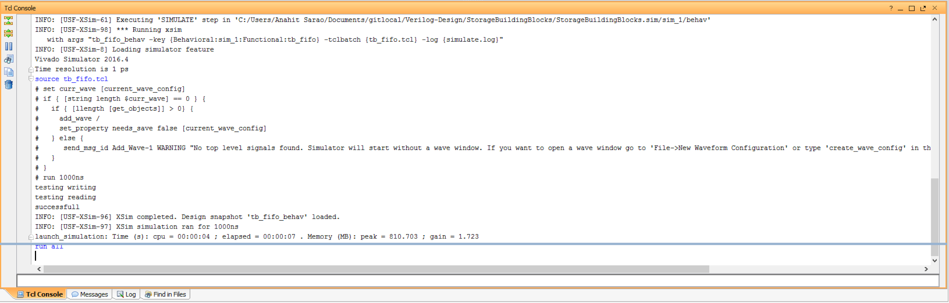

***FPGA Test Plan***

*FIFO:* Hardware validation was performed using the Nexys 4 board. For this to be possible, modules such as the clock generator, button debouncer, and constraints file were implemented. The 4 sec clk was disabled and a switch was used to simulate the clock. The LED lights were used to denote when the FIFO was full or empty. The combination of switches and LEDs were used to show which values were either being written or read from the FIFO. The read and write enables were assigned a pair of switches and LEDs. One major problem during the bitstream compilation was extra outputs and inputs were defined within the top level module but were never assigned within the XDC file. This caused errors and a bitstream generation failure, this was corrected after speaking with the TA and learning extra inputs and outputs can not be declared even if the design does not use them. Figure five and six shows the the FIFO board verification during the read and write stages.

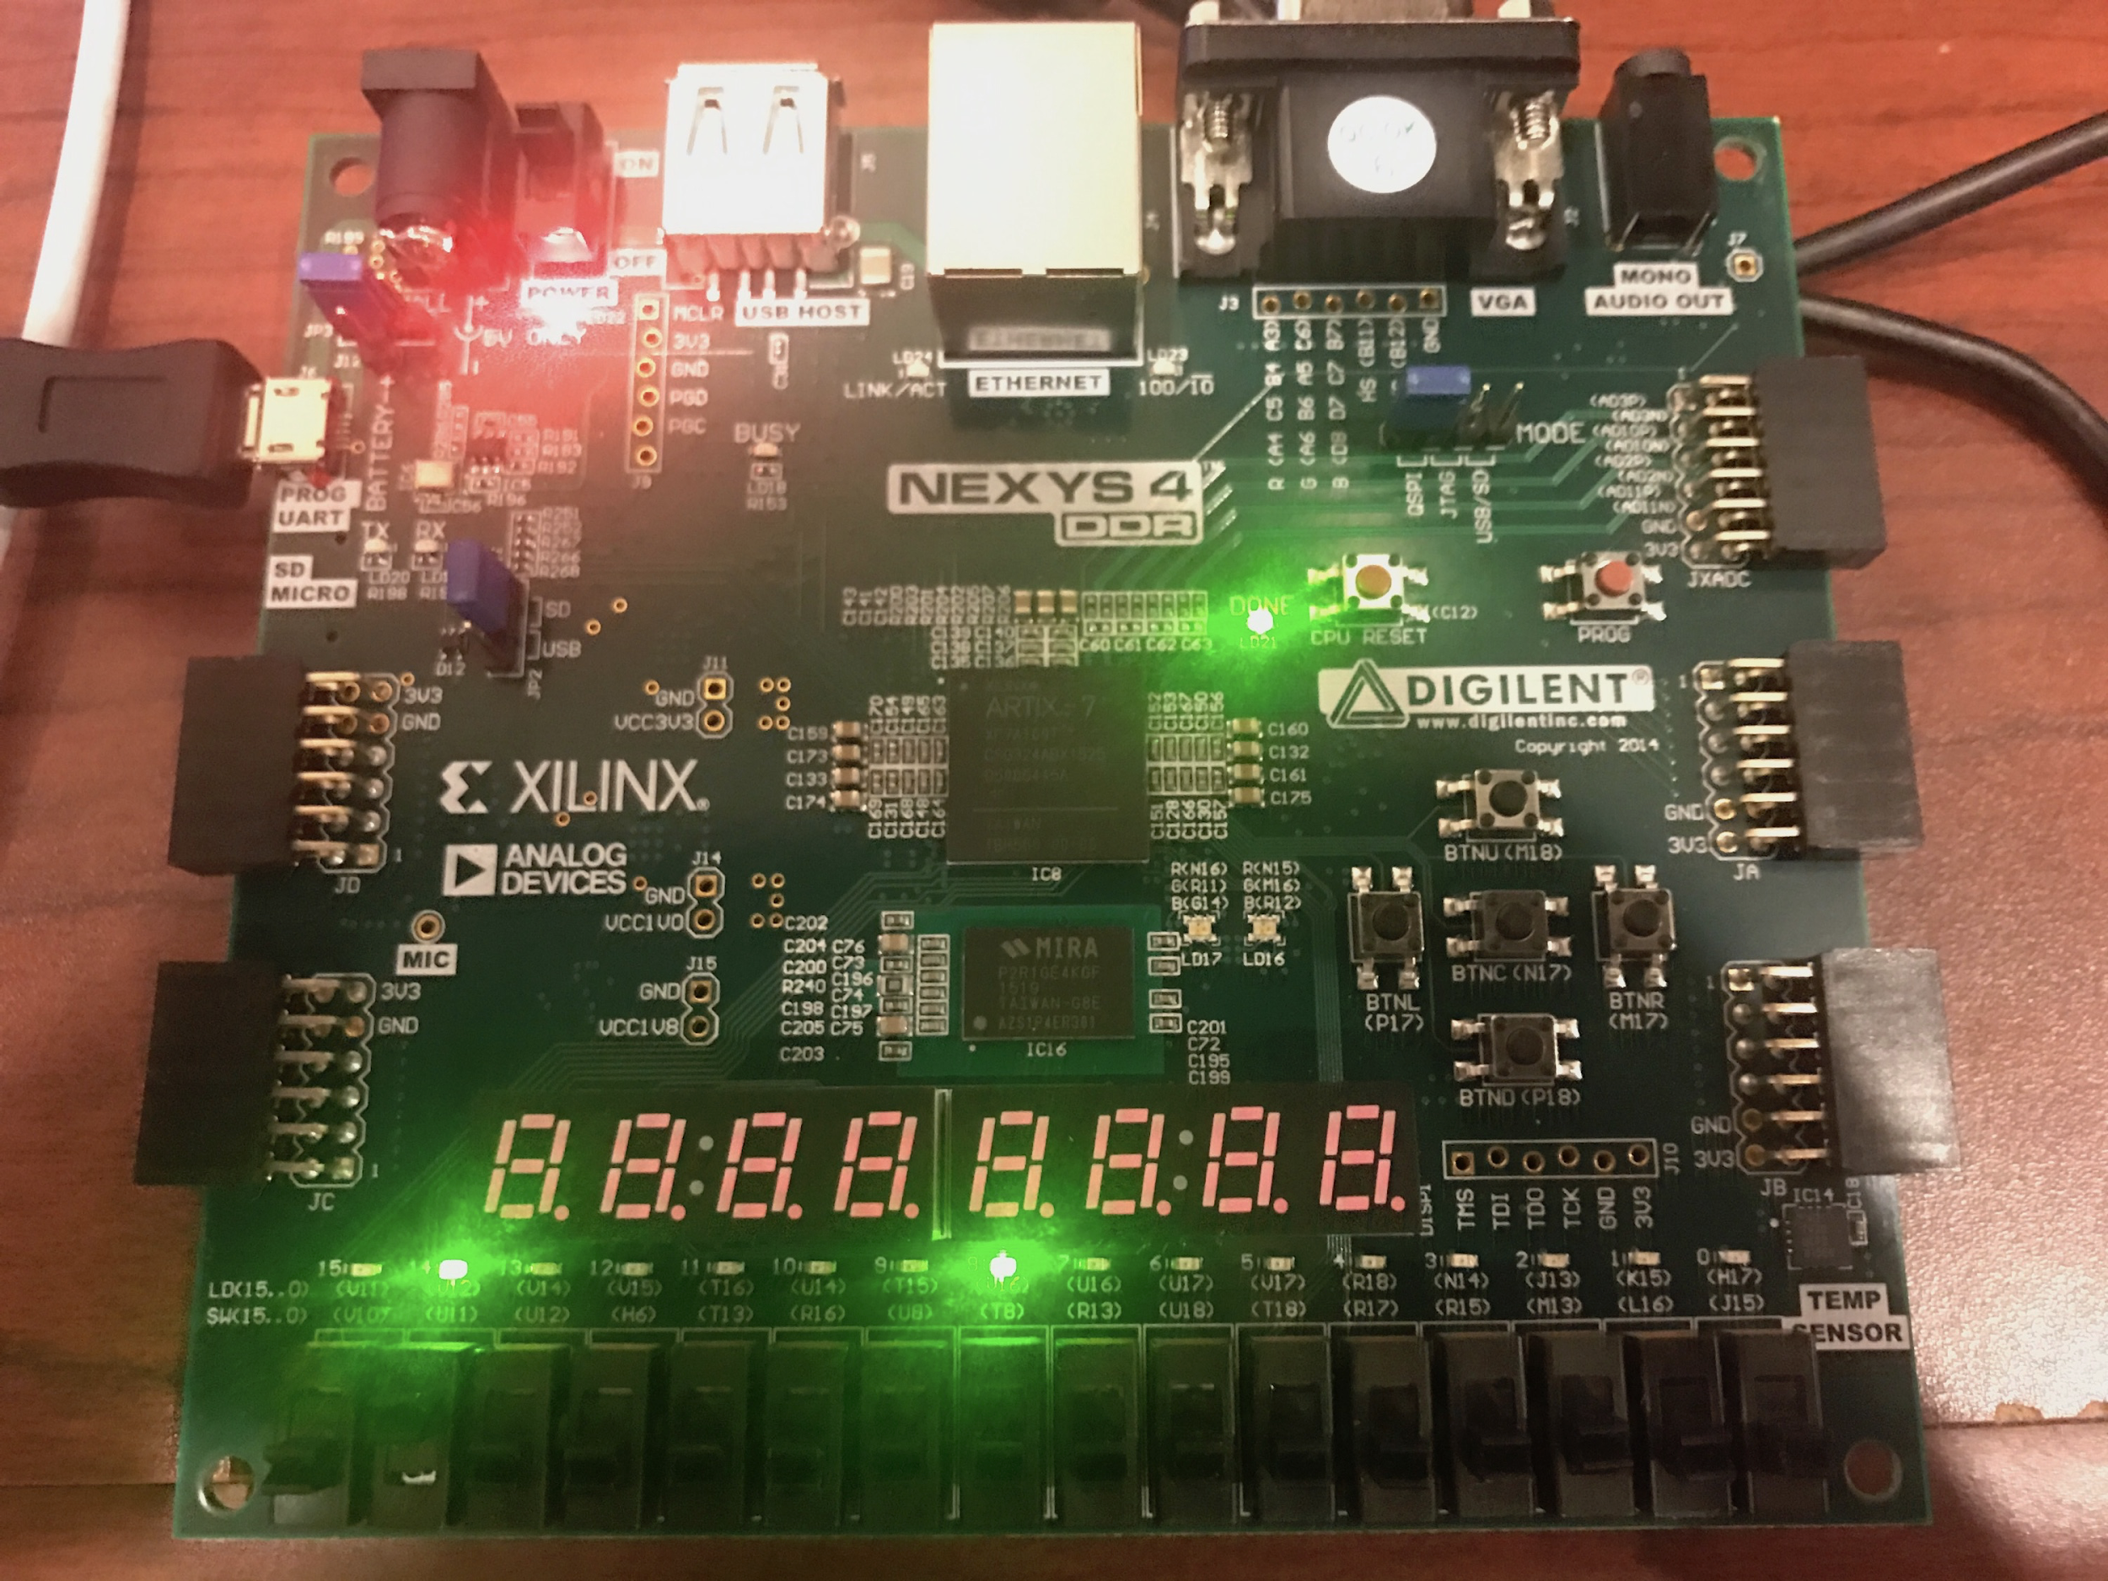

Figure 5: FIFO read enabled while FIFO is full

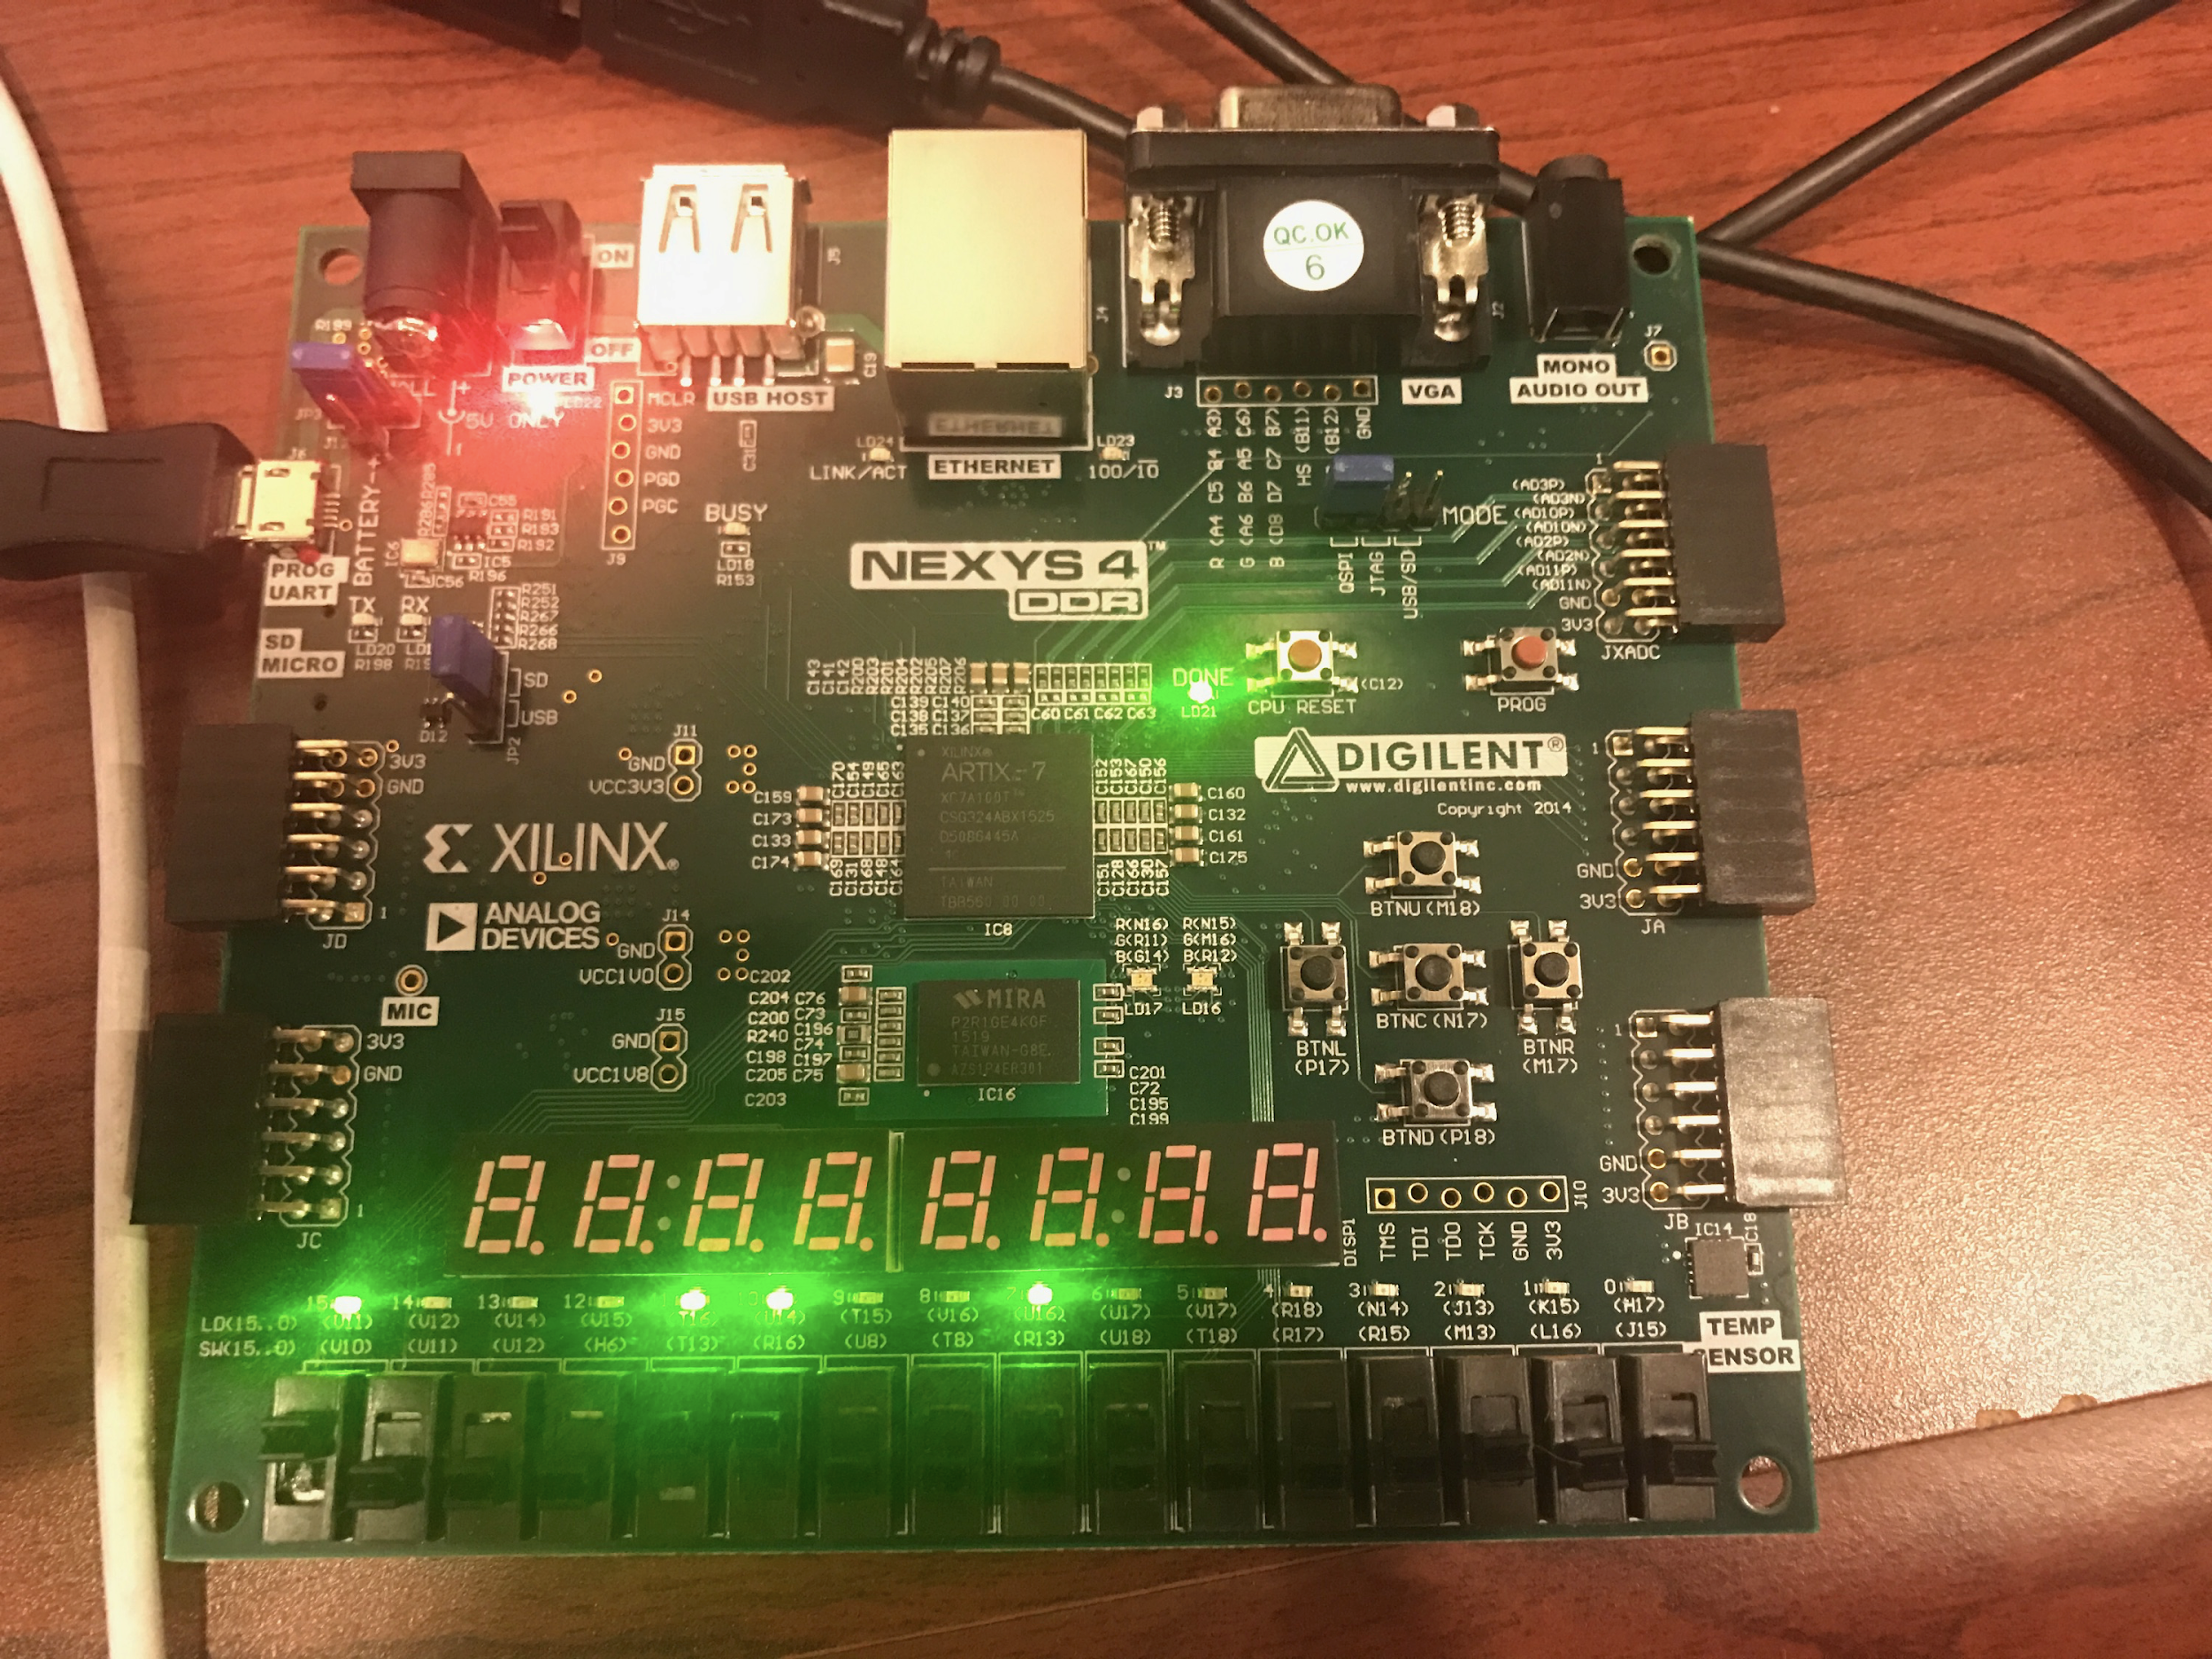

Figure 6: FIFO empty plus write enabled ready to store value chosen

***Conclusion***

In conclusion, the register file worked as intended. It passed the three tests that were implemented to verify its functionality. Each read and write port functioned properly as did the write enable ports. Additionally, the write address worked as intended when assigned the same port as the read addresses. The value was read into the read data port as the clock edge came upon a rising edge. The test bench also performed as expected with a success value being printed as well. For the FIFO all verification was performed successfully. Only minor changes to the testbench were needed during demonstration time. Extra figures are provided within the appendix to show verification in detail.

***Appendix***

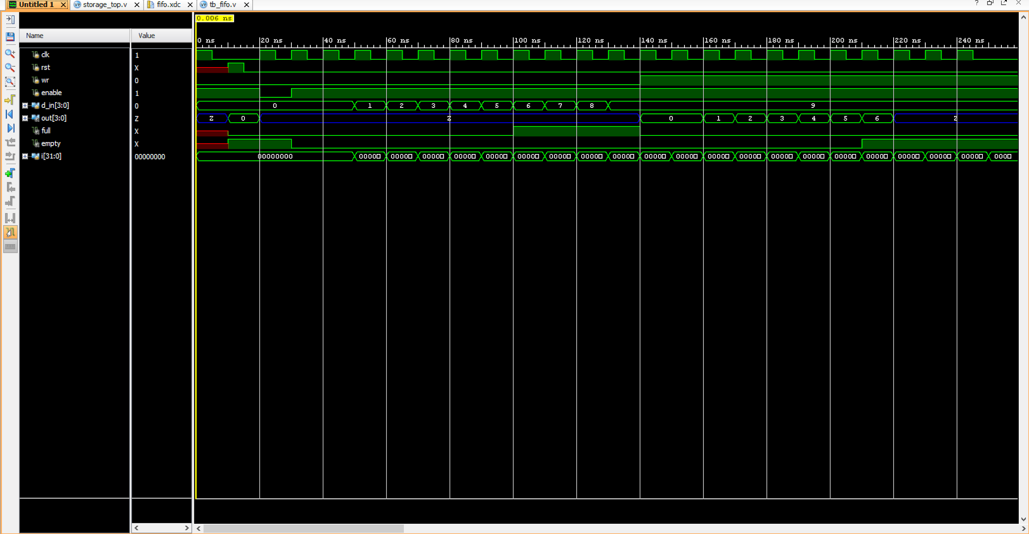

Figure 7: FIFO Simulation

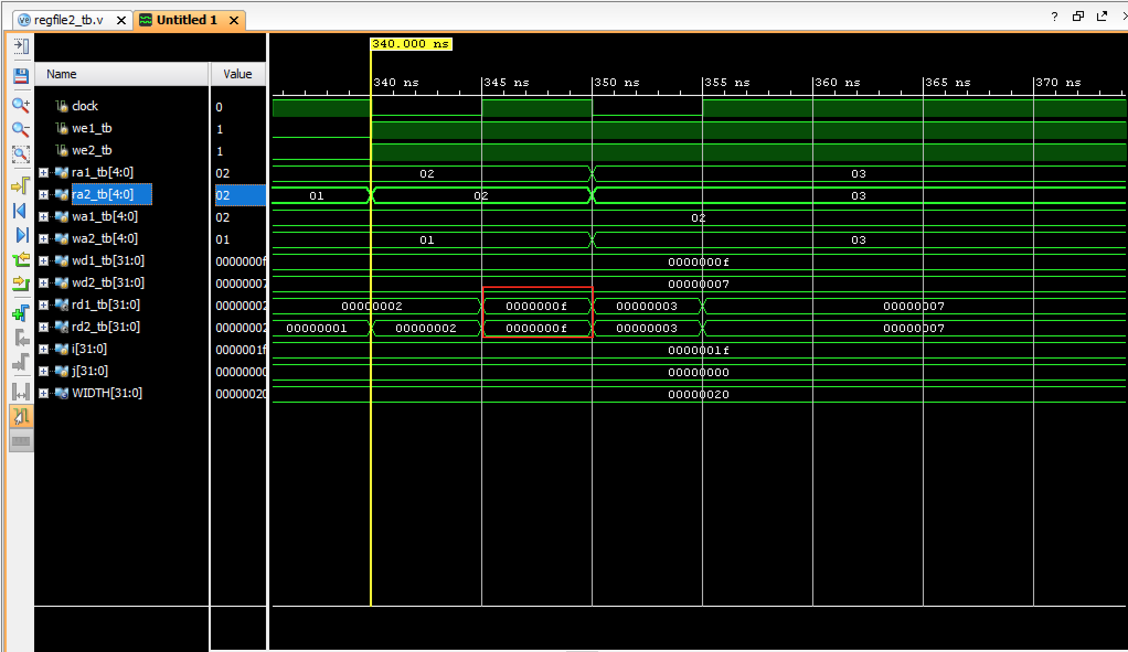

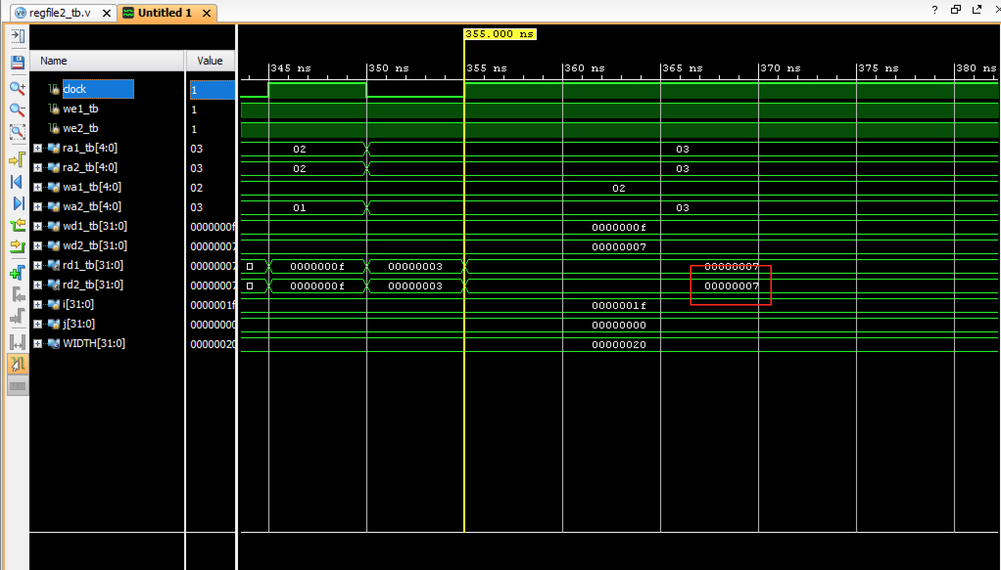

Figure 8: Register File Simulation showing the read data as it changes after 1 clock cycle from changing the write address and read address ports

***Source Code***

**Regfile2.v**

`timescale 1ns / 1ps

module regfile2(

input clk,

input we1, input we2,

input [4:0] ra1, input [4:0] ra2, input [4:0] wa1, input [4:0] wa2,

input [31:0] wd1, input [31:0] wd2,

output [31:0] rd1, output [31:0] rd2);

reg [31:0] rf [31:0];//2-D (32x32) array

always @(posedge clk)

begin

if (we1) rf[wa1] <= wd1;

if (we2) rf[wa2] <= wd2;

end

assign rd1 = (ra1 != 0) ? rf[ra1] : 0;//read 1

assign rd2 = (ra2 != 0) ? rf[ra2] : 0;//read 2

Endmodule

**regfile2_tb.v**

`timescale 1ns / 1ns

module regfile2_tb ();

parameter WIDTH = 32;

reg clock, we1_tb, we2_tb;

reg [4:0] ra1_tb, ra2_tb, wa1_tb, wa2_tb;

reg [WIDTH -1:0]wd1_tb, wd2_tb;

wire[WIDTH -1:0]rd1_tb, rd2_tb;

regfile2 DUT( .clk(clock), .we1(we1_tb), .we2(we2_tb),

.ra1(ra1_tb), .ra2(ra2_tb), .wa1(wa1_tb), .wa2(wa2_tb),

.wd1(wd1_tb), .wd2(wd2_tb), .rd1(rd1_tb), .rd2(rd2_tb));

task cycle;

begin

clock=0;

#5;

clock=1;

#5;

end

endtask

integer i=0;

integer j=0;

initial

begin

we1_tb = 1;

we2_tb = 1;

cycle;

for(i=0; i<31; i=i+1)

begin

//j=i+1;

wa1_tb = i;

wa2_tb = i+1;

wd1_tb = i;

wd2_tb = i+1;

ra1_tb = i;

ra2_tb = i+1;

cycle;

if((rd1_tb!=wd1_tb)||(rd2_tb!=wd2_tb))

begin

$display ("Error: Read data doesn't equal write data");

end

end

$display ("Test enable");

we1_tb=0;

wa1_tb = 2;

wd1_tb = 15;

ra1_tb = 2;

cycle;

if(rd1_tb == 15)

begin

$display ("Error: Enable activated");

end

we2_tb=0;

wa2_tb = 1;

wd2_tb = 7;

ra2_tb = 1;

cycle;

if(rd2_tb == 7)

begin

$display ("Error: Enable activated");

end

$display ("Test write address = read address");

we1_tb=1;

we2_tb=1;

wa1_tb=2;

ra1_tb=2;

ra2_tb=2;

cycle;

wa2_tb=3;

ra1_tb=3;

ra2_tb=3;

cycle;

$display("Success");

$stop;

end

endmodule

***Fifo.v***

`timescale 1ns / 1ps

//////////////////////////////////////////////////////////////////////////////////

// Company:

// Engineer:

//

// Create Date: 04/05/2017 02:58:09 PM

// Design Name:

// Module Name: storage_top

// Project Name:

// Target Devices:

// Tool Versions:

// Description:

//

// Dependencies:

//

// Revision:

// Revision 0.01 - File Created

// Additional Comments:

//

//////////////////////////////////////////////////////////////////////////////////

module storage_top(input clk100MHz, setCLK, rst, wr, enable,

input [3:0] in,

output [3:0] out,

output full, empty,

output wnrLED, enLED,

output [3:0] inLED

);

wire dbbutton;

wire DONT_USE, clk_5KHz;

assign wnrLED = wr;

assign enLED = enable;

assign inLED = in;

clk_gen u5 (.clk100MHz(clk100MHz), .rst(rst), .clk_4sec(DONT_USE), .clk_5KHz(clk_5KHz));

button_debouncer #(16) bd(.clk(clk_5KHz), .button(setCLK), .debounced_button(dbbutton));

fifo Q1(.d_in(in), .d_out(out), .empty(empty), .full(full), .clk(dbbutton), .rst(rst), .wr(wr), .enable(enable));

endmodule

module fifo(d_in,d_out,empty,full,clk,rst,wr,enable);

input clk, rst, wr, enable;

input [3:0] d_in;

output reg [3:0] d_out;

output reg full, empty;

reg [3:0] r_ptr, w_ptr;

reg [3:0] mem [7:0];

always @(posedge clk or posedge rst) begin

if (rst)

begin

r_ptr <= 0; w_ptr <= 0; d_out <= 0;

end

else if (!enable)

begin

d_out <= 'bz;

end

else if (wr && !empty)

begin

d_out <= mem[r_ptr[2:0]];

r_ptr <= r_ptr + 1;

end

else if (!wr && !full)

begin

mem[w_ptr[2:0]] <= d_in;

w_ptr <= w_ptr + 1;

end

else

begin

d_out <= 'bz;

end

end

always @(r_ptr, w_ptr)

begin

if (r_ptr == w_ptr)

begin

empty = 1;

full = 0;

end

else if (r_ptr[2:0] == w_ptr[2:0])

begin

empty = 0;

full = 1;

end

else

begin

empty = 0;

full = 0;

end

end

endmodule

module clk_gen(clk100MHz, rst, clk_4sec, clk_5KHz); // start clk_gen

input clk100MHz, rst;

output clk_4sec, clk_5KHz;

reg clk_4sec, clk_5KHz;

integer count, count1;

always@(posedge clk100MHz)

begin

if(rst)

begin

count = 0;

count1 = 0;

clk_4sec = 0;

clk_5KHz =0;

end

else

begin

if(count == 200000000) begin

clk_4sec = ~clk_4sec;

count = 0;

end

if(count1 == 10000) begin

clk_5KHz = ~clk_5KHz;

count1 = 0;

end

count = count + 1;

count1 = count1 + 1;

end

end

endmodule // end clk_gen

module button_debouncer #(parameter depth = 16) (

input wire clk, /* 5 KHz clock */

input wire button, /* Input button from constraints */

output reg debounced_button

);

localparam history_max = (2**depth)-1;

/* History of sampled input button */

reg [depth-1:0] history;

always @ (posedge clk)

begin

/* Move history back one sample and insert new sample */

history <= { button, history[depth-1:1] };

/* Assert debounced button if it has been in a consistent state throughout history */

debounced_button <= (history == history_max) ? 1'b1 : 1'b0;

end

endmodule

***Fifo.xdc***

########################################################

# Design Constraint File #

# FILE NAME: voting_machine_fpga.xdc #

# DATE: 7/25/14 #

########################################################

set_property -dict { PACKAGE_PIN E3 IOSTANDARD LVCMOS33 } [get_ports { clk100MHz }];

create_clock -add -name sys_clk_pin -period 10.00 -waveform {0 5} [get_ports {clk100MHz}];

set_property -dict { PACKAGE_PIN U11 IOSTANDARD LVCMOS33 } [get_ports { wr }];

set_property -dict { PACKAGE_PIN V10 IOSTANDARD LVCMOS33 } [get_ports { enable }];

set_property -dict { PACKAGE_PIN V12 IOSTANDARD LVCMOS33 } [get_ports { wnrLED }];

set_property -dict { PACKAGE_PIN V11 IOSTANDARD LVCMOS33 } [get_ports { enLED }];

set_property -dict { PACKAGE_PIN R16 IOSTANDARD LVCMOS33 } [get_ports { in[0] }];

set_property -dict { PACKAGE_PIN T13 IOSTANDARD LVCMOS33 } [get_ports { in[1] }];

set_property -dict { PACKAGE_PIN H6 IOSTANDARD LVCMOS33 } [get_ports { in[2] }];

set_property -dict { PACKAGE_PIN U12 IOSTANDARD LVCMOS33 } [get_ports { in[3] }];

set_property -dict { PACKAGE_PIN U14 IOSTANDARD LVCMOS33 } [get_ports { inLED[0] }];

set_property -dict { PACKAGE_PIN T16 IOSTANDARD LVCMOS33 } [get_ports { inLED[1] }];

set_property -dict { PACKAGE_PIN V15 IOSTANDARD LVCMOS33 } [get_ports { inLED[2] }];

set_property -dict { PACKAGE_PIN V14 IOSTANDARD LVCMOS33 } [get_ports { inLED[3] }];

set_property -dict { PACKAGE_PIN H17 IOSTANDARD LVCMOS33 } [get_ports { out[0] }];

set_property -dict { PACKAGE_PIN K15 IOSTANDARD LVCMOS33 } [get_ports { out[1] }];

set_property -dict { PACKAGE_PIN J13 IOSTANDARD LVCMOS33 } [get_ports { out[2] }];

set_property -dict { PACKAGE_PIN N14 IOSTANDARD LVCMOS33 } [get_ports { out[3] }];

set_property -dict { PACKAGE_PIN V16 IOSTANDARD LVCMOS33 } [get_ports { full }];

set_property -dict { PACKAGE_PIN U16 IOSTANDARD LVCMOS33 } [get_ports { empty }];

set_property -dict { PACKAGE_PIN M18 IOSTANDARD LVCMOS33 } [get_ports { rst }];

set_property -dict { PACKAGE_PIN P18 IOSTANDARD LVCMOS33 } [get_ports { setCLK }];

***Tb_fifo.v***

`timescale 1ns / 1ps

//////////////////////////////////////////////////////////////////////////////////

// Company:

// Engineer:

//

// Create Date: 04/05/2017 03:23:25 PM

// Design Name:

// Module Name: tb_fifo

// Project Name:

// Target Devices:

// Tool Versions:

// Description:

//

// Dependencies:

//

// Revision:

// Revision 0.01 - File Created

// Additional Comments:

//

//////////////////////////////////////////////////////////////////////////////////

module tb_fifo;

reg clk, rst, wr, enable;

reg [3:0] d_in;

wire [3:0] out;

wire full, empty;

fifo DUT(.d_in(d_in), .d_out(out), .empty(empty), .full(full),.clk(clk), .rst(rst), .wr(wr), .enable(enable));

task clkhit; begin

clk = 1; #5; clk = 0; #5; end

endtask

task rst_global; begin

rst = 1; #5; rst = 0; #5; end

endtask

integer i = 0;

initial

begin

enable = 1; wr = 0; d_in = 0; clkhit;

rst_global;

if (out != 0)//checking if out does not equal 0

begin

$display ("error");

$stop;

end

enable = 0;

clkhit;

if (out != d_in)//checking if output equals input

begin

$display ("error");

$stop;

end

$display("testing writing");

enable = 1; wr = 0; clkhit;

for (i=0; i<10; i=i+1)//testing the write fiunction

begin

d_in = i;

clkhit;

end

if (!full)//checking if full

begin

$display ("error");

$stop;

end

$display("testing reading");

wr = 1; clkhit;

for (i=0; i<10; i=i+1)//testing the read function

begin

clkhit;

if (out != i)

begin

$display ("error");

end

end

if (!empty)//checking for empty

begin

$display ("error");

$stop;

end

$display("successfull");

end

endmodule